

Aston All Saints Church of England Primary School



YEAR 2 Mathematics

Key Instant Recall Facts

KIRFs

To develop your child’s fluency and mental maths skills, we are introducing KIRFs (Key Instant Recall Facts) throughout school. KIRFS are a way of helping your child to learn by heart, key facts and information which they need to have instant recall of.

KIRFs are designed to support the development of mental maths skills that underpin much of the maths work in our school. They are particularly useful when calculating, adding, subtracting, multiplying or dividing. They contain number facts such as number bonds and times tables that need constant practise and rehearsal, so children can recall them quickly and accurately.

Instant recall of facts helps enormously with mental agility in maths lessons. When children move onto written calculations, knowing these key facts is very beneficial. For your child to become more efficient in recalling them easily, they need to be practised frequently and for short periods of time.

Each half term, children will focus on a Key Instant Recall Fact (KIRF) to practise and learn at home for the half term. They will also be available on our school website under the maths section and each child will receive a copy to keep at home. The KIRFs include practical ideas to assist your child in grasping the key facts and contain helpful suggestions of ways in which you could make this learning interesting and relevant. They are not designed to be a time-consuming task and can be practised anywhere – in the car, walking to school, etc. Regular practice - little and often – helps children to retain these facts and keep their skills sharp. Throughout the half term, the KIRFs will also be practised in school and your child’s teacher will assess whether they have been retained.

Over their time at primary school, we believe that - if the KIRFs are developed fully - children will be more confident with number work, understand its relevance, and be able to access the curriculum much more easily. They will be able to apply what they have learnt to a wide range of problems that confront us regularly.


Key Instant Recall Facts

YEAR 2 – Autumn 1

I know number bonds to 20

By the end of this half term, children should know the following facts. The aim is for them to recall these facts instantly.


0+20=20 |  | 20+0=20 |  | 20 | –0=20 | 20 | –20=0
1+19=20 |  | 19 | +1=20 | 20 | –1=19 | 20 | –19=1
2+18=20 |  | 18 | +2=20 | 20 | –2=18 | 20 | –18=2
3+17=20 |  | 17+3=20 |  | 20 | –3=17 | 20 | –17=3
4 | +16=20 | 16 | +4=20 | 20 | –4=16 | 20 | –16=4
5 | +15=20 | 15 | +5=20 | 20 | –5=15 | 20 | –15=5
6 | +14=20 | 14 | +6=20 | 20 | –6=14 | 20 | –14=6
7+13=20 |  | 13+7=20 |  | 20 | –7=13 | 20 | –13=7
8 | +12=20 | 12+8=20 |  | 20 | –8=12 | 20 | –12=8
9 | +11=20 | 11+9=20 |  | 20 | –9=11 | 20 | –11=9
10+10=20 |  |  |  | 20 | –10=10

They should be able to answer these questions in any order, including missing number questions e.g. 19 + ⃞= 20 or 20 - ⃞= 8

Key Vocabulary

What do I add to 5 to

make 20?

What is 20 take away

6?

What is 3 less than

20?

How many more than

16 is 20?

Top Tips

The secret to success is practising little and often. Use time wisely. Can you practise these KIRFs while walking to school or during a car journey? You do not need to practise them all at once; perhaps you could have a fact of the day.

Use what you already know – Use number bonds to 10 (e.g. 7 + 3 = 10) to work out related number bonds to 20 (e.g. 17 + 3 = 20).

Use practical resources – Make collections of 20 objects. Ask questions such as, ‘How many more conkers would I need to make 20?’

Make a poster – We use Numicon at school. You can find pictures of the Numicon shapes here: www.bit.ly/NumiconPictures – your child could make a poster showing the different ways of making 20.

Play Games – You can play number bond pairs online at www.conkermaths.org and then see how many questions you can answer in just one minute.

Key Instant Recall Facts

YEAR 2 – Autumn 2

I know the multiplication and division facts for the 2 times table

By the end of this half term, children should know the following facts. The aim is for them to recall these facts instantly.


2 x 1 = 2 | 2÷2=1
2 x 2 = 4 | 4÷2=2
2 x 3 = 6 | 6÷2=3
2 x 4 = 8 | 8÷2=4
2 x 5 = 10 | 10÷2=5
2 x 6 = 12 | 12÷2=6
2 x 7 = 14 | 14 | ÷ 2 | = 7
2 x 8 = 16 | 16 | ÷ 2 | = 8
2 x 9 = 18 | 18 | ÷ 2 | = 9
2 x 10 =20 | 20÷2=10
2 x 11 = 22 | 22÷2=11
2 x 12 = 24 | 24÷2=12

Key Vocabulary

What is 2 multiplied by

7?

What is 2 times 9?

What is 12 divided by

2?

They should be able to answer these questions in any order, including missing number questions e.g. 2 x ⃞= 8 or ⃞÷ 2 = 6

Top Tips - The secret to success is practising little and often. Use time wisely. Can you practise these KIRFs while walking to school or during a car journey? You do not need to practise them all at once; perhaps you could have a fact of the day.

Songs and Chants – You can buy Times Tables CDs or find multiplication songs and chants online. You can also use Education City songs and websites www.timestables.co.uk and www.timestables.me.uk

Use what you already know – If your child knows that 2 x 5 = 10, they can use this fact to work out that 2 x 6 = 12

Test the Parent – Your child can make up their own tricky division questions for you e.g.

What is 18 divided by 2? They need to be able to multiply to create these questions.

Use memory tricks – For those hard-to-remember facts, www.multiplication.com has some strange picture stories to help children remember.

Play Games – You can play number bond pairs online at www.conkermaths.org and then see how many questions you can answer in just one minute

Key Instant Recall Facts

YEAR 2 – Spring 1

I know doubles and halves of numbers to 20

By the end of this half term, children should know the following facts. The aim is for them to recall these facts instantly.

0+0=0 |  | ½ of 0 = 0
1+1=2 |  | ½ of 2 = 1 | 11+11=22
2+2=4 |  | ½ of 4 = 2 | 12+12=24
3+3=6 |  | ½ of 6 = 3 | 13+13=26 |  |  | Key Vocabulary
4+4=8 |  | ½ of 8 = 4 | 14+14=28 |  |  | Key Vocabulary
 |  | ½ of 8 = 4 |  |  | What is double 9?
5 + 5 | = 10 | ½ of 10 = 5 | 15 | +15=30
 |  |  |  |  | What is half of 14?
6 + 6 | = 12 | ½ of 12 = 6 | 16 | +16=32
7+7=14 |  | ½ of 14 = 7 | 17+17=34
8 + 8 | = 16 | ½ of 16 = 8 | 18 | +18=36
9 + 9 | = 18 | ½ of 18 = 9 | 19 | +19=38
10+10=20 |  | ½ of 20 = 10 | 20+20=40

Top Tips - The secret to success is practising little and often. Use time wisely. Can you practise these KIRFs while walking to school or during a car journey? You do not need to practise them all at once; perhaps you could have a fact of the day. If you would like more ideas, please speak to your child’s teacher.

Use what you already know – Encourage your child to find the connection between the 2 times table and double facts.

Ping Pong – In this game, the parents says ‘Ping,’ and the child replies ‘Pong.’ Then the parent says a number and the child doubles it. For a harder version, the adult can say, ‘Pong.’ The child replies, ‘Ping,’ and then halves the next number given.

Play Online – Go to www.educationcity.com or www.conkermaths.org

Key Instant Recall Facts

YEAR 2 – Spring 2

I know the multiplication and division facts for the 10 times table.

By the end of this half term, children should know the following facts. The aim is for them to recall these facts instantly.

10 x 1 = 10 | 10÷10=1
10 x 2 = 20 | 20÷10=2
10 x 3 = 30 | 30÷10=3
10 x 4 = 40 | 40÷10=4
10 x 5 = 50 | 50÷10=5
10 x 6 = 60 | 60÷10=6
10 x 7 = 70 | 70÷10=7
10 x 8 = 80 | 80÷10=8
10 x 9 = 90 | 90÷10=9
10 x 10 = 100 | 100÷10=10
10 x 11 = 110 | 110÷10=11
10 x 12 = 120 | 120÷10=12

Key Vocabulary

What is 10 multiplied

by 3?

What is 10 times 9?

What is 70 divided by

10?

They should be able to answer these questions in any order, including missing number questions e.g. 10 x ⃞= 80 or ⃞÷ 10 = 6

Top Tips - The secret to success is practising little and often. Use time wisely. Can you practise these KIRFs while walking to school or during a car journey? You do not need to practise them all at once; perhaps you could have a fact of the day.

Pronunciation – Make sure that your child is pronouncing the numbers correctly and not getting confused between thirteen and thirty.

Songs and Chants – You can buy Times Tables CDs or find multiplication songs and chants online. You can also use Education City songs and websites www.timestables.co.uk and www.timestables.me.uk

Test the Parent – Your child can make up their own tricky division questions for you e.g.

What is 70 divided by 10? They need to be able to multiply to create these questions.

Apply these facts to real-life situations – How many toes are in your house? What other multiplication and division questions can your child make up?

Key Instant Recall Facts

YEAR 2 – Summer 1

I can tell the time using quarter past and quarter to

By the end of this half term, children should know the following facts. The aim is for them to recall these facts instantly.

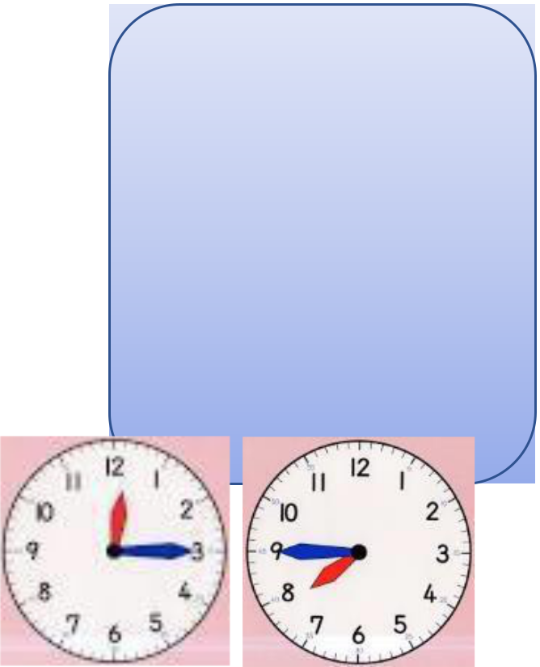

Children need to be able to tell the time using a clock with hands.

This target can be broken down into several steps.

- I can tell the time to the nearest hour.

- I can tell the time to the nearest half hour.

- I can tell the time to the nearest quarter hour.

Top Tips

Key Vocabulary Twelve o’clock Half past two Quarter past three Quarter to 9

The secret to success is practising little and often. Use time wisely. Can you practise these KIRFs while walking to school or during a car journey? You do not need to practise them all at once; perhaps you could have a fact of the day. If you would like more ideas, please speak to your child’s teacher.

Talk about time – Discuss what time things happen. When does your child wake up? What time do they eat breakfast? Make sure that you have an analogue clock visible in your house or that your child wears a watch with hands.

Ask your child the time regularly – You could also give your child some responsibility for watching the clock:

‘The cakes need to come out of the oven at quarter past four.’ ‘We need to leave the house at half past eight.’

Key Instant Recall Facts

YEAR 2 – Summer 2

I know the multiplication and division facts for the 5 times table

By the end of this half term, children should know the following facts. The aim is for them to recall these facts instantly.

5 x 1 = 5 |  | 5÷5=1
5 x 2 = 10 |  | 10÷5=2
5 x 3 = 15 |  | 15÷5=3
5 x 4 = 20 |  | 20÷5=4
5 x 5 = 25 |  | 25÷5=5
5 x 6 | = 30 | 30÷5=6
5 x 7 = 35 |  | 35÷5=7
5 x 8 | = 40 | 40÷5=8
5 x 9 | = 45 | 45÷5=9
5 x 10 = 50 |  | 50÷5=10
5 x 11 = 55 |  | 55÷5=11
5 x 12 = 60 |  | 60÷5=12

Key Vocabulary

What is 5 multiplied by

7?

What is 5 times 9?

What is 60 divided by

5?

They should be able to answer these questions in any order, including missing number questions e.g. 5 x ⃞= 40 or ⃞÷ 5 = 9

Top Tips - The secret to success is practising little and often. Use time wisely. Can you practise these KIRFs while walking to school or during a car journey? You do not need to practise them all at once; perhaps you could have a fact of the day. If you would like more ideas, please speak to your child’s teacher.

Songs and Chants – You can buy Times Tables CDs or find multiplication songs and chants online. You can also use Education City songs and websites www.timestables.co.uk and www.timestables.me.uk

Spot patterns – What patterns can your child spot in the 5 times table? Are there any similarities with the 10 times table?

Test the Parent – Your child can make up their own tricky division questions for you e.g.

What is 45 divided by 5? They need to be able to multiply to create these questions.

Use memory tricks – For those hard-to-remember facts, www.multiplication.com has some strange picture stories to help children remember.

