

Aston All Saints Church of England Primary School



YEAR 3 Mathematics

Key Instant Recall Facts

KIRFs

To develop your child’s fluency and mental maths skills, we are introducing KIRFs (Key Instant Recall Facts) throughout school. KIRFS are a way of helping your child to learn by heart, key facts and information which they need to have instant recall of.

KIRFs are designed to support the development of mental maths skills that underpin much of the maths work in our school. They are particularly useful when calculating, adding, subtracting, multiplying or dividing. They contain number facts such as number bonds and times tables that need constant practise and rehearsal, so children can recall them quickly and accurately.

Instant recall of facts helps enormously with mental agility in maths lessons. When children move onto written calculations, knowing these key facts is very beneficial. For your child to become more efficient in recalling them easily, they need to be practised frequently and for short periods of time.

Each half term, children will focus on a Key Instant Recall Fact (KIRF) to practise and learn at home for the half term. They will also be available on our school website under the maths section and each child will receive a copy to keep at home. The KIRFs include practical ideas to assist your child in grasping the key facts and contain helpful suggestions of ways in which you could make this learning interesting and relevant. They are not designed to be a time-consuming task and can be practised anywhere – in the car, walking to school, etc. Regular practice - little and often – helps children to retain these facts and keep their skills sharp. Throughout the half term, the KIRFs will also be practised in school and your child’s teacher will assess whether they have been retained.

Over their time at primary school, we believe that - if the KIRFs are developed fully - children will be more confident with number work, understand its relevance, and be able to access the curriculum much more easily. They will be able to apply what they have learnt to a wide range of problems that confront us regularly.


Key Instant Recall Facts

YEAR 3 – Autumn 1

I know number bonds for all numbers to 20

By the end of this half term, children should know the following facts. The aim is for them to recall these facts instantly.

2 + 9 = 11 |  |  |  | 5 | + 9 | = 14 | Example fact
3 | + 8 | = | 11 | 6 | + 8 | = 14 | family:
4 + 7 = 11 |  |  |  | 7 + 7 = 14 |  |  | 6 + 9 = 15
5 + 6 = 11 |  |  |  | 6 + 9 = 15 |  |  | 9 + 6 = 15
3 + 9 = 12 |  |  |  | 7 + 8 = 15 |  |  | 15 – 9 = 6
4 + 8 = 12 |  |  |  | 7 + 9 = 16 |  |  | 15 – 6 = 9
5 | + 7 = 12 |  |  | 8 | + 8 = 16
6 | + 6 = 12 |  |  | 8 | + 9 | = 17 | Example of
4 | + 9 = 13 |  |  | 9 | + 9 | = 18 | other facts:
5 | + 8 = 13 |  |  |  |  |  | 4 + 5 = 9
6 | + 7 = 13 |  |  |  |  |  | 13 + 5 = 18
 |  |  |  |  |  |  | 19 – 7 = 12
Top Tips

Key Vocabulary


What do I add to 5 to

make 19?

What is 17 take away

6?

What is 13 less than

15?

How many more than

8 is 11?

What is the difference

between 9 and 13?

The secret to success is practising little and often. Use time wisely. Can you practise these KIRFs while walking to school or during a car journey? You do not need to practise them all at once; perhaps you could have a fact of the day.

Buy one get three free – If your child knows one fact (e.g. 8 + 5 = 13), can they tell you the other three facts in the same fact family?

Use doubles and near doubles – If you know that 6 + 6 = 12, how can you work out 6 + 7?

What about 5 + 7?

Play Games – There are missing number questions at www.conkermaths.org and see how many questions you can answer in just one minute.

Key Instant Recall Facts

YEAR 3 – Autumn 2

I know the multiplication and division facts for the 3 times table

By the end of this half term, children should know the following facts. The aim is for them to recall these facts instantly.

3 x 1 = 3 | 1 x 3 = 3 | 3 ÷ 3 = 1 |  |  | 3 ÷ 1 = 3
3 x 2 = 6 | 2 x 3 = 6 | 6 ÷ 3 = 2 |  |  | 6 ÷ 2 = 3
3 x 3 = 9 | 3 x 3 = 9 | 9 ÷ 3 = 3 |  |  | 9 ÷ 3 = 3 |  | Key Vocabulary
3 x 4 = 124 x 3 = 12 |  | 12 ÷ 3 = 4 | 12 ÷ 4 = 3 |  |  |  | What is 3
3 x 5 = 15 5 x 3 = 15 |  | 15 ÷ 3 = 5 | 15 ÷ 5 = 3
 |  | 15 ÷ 3 = 5 |  |  |  |  | multiplied by 8?
3 x 6 = 18 | 6 x 3 = 18 | 18 ÷ 3 = 6 | 18 ÷ 6 = 3
 |  |  |  |  |  | What is 8 times 3?
3 x 7 = 21 | 7 x 3 = 21 | 21 ÷ 3 = 7 | 21 ÷ 7 = 3
3 x 8 = 24 | 8 x 3 = 24 | 24 ÷ 3 = 8 |  |  | 24 ÷ 8 = 3 |  | What is 24
3 x 9 = 27 | 9 x 3 = 27 | 27 ÷ 3 = 9 |  |  | 27 ÷ 9 = 3 |  | divided by 3?
3 x 10 = 30 | 10 x 3 = 30 | 30 ÷ 3 = 10 30 ÷ 10 = 3
3 x 11 = 33 | 11 x 3 = 33 | 33 ÷ 3 = 11 |  |  | 33 ÷ 11 = 3
3 x 12 = 36 | 12 x 3 = 36 | 36 ÷ 3 = 12 |  | 33 ÷ 12 = 3


They should be able to answer these questions in any order, including missing number questions e.g. 3 x ⃞= 18 or ⃞÷ 3 = 11

Top Tips - The secret to success is practising little and often. Use time wisely. Can you practise these KIRFs while walking to school or during a car journey? You do not need to practise them all at once; perhaps you could have a fact of the day.

Songs and Chants – You can buy Times Tables CDs or find multiplication songs and chants online. You can also use Education City songs and websites www.timestables.co.uk and www.timestables.me.uk

Buy one get three free – If your child knows one fact (e.g. 3 x 5 = 15), can they tell you the other three facts in the same fact family?

WARNING! – When creating fact families, children sometimes get confused by the order of the numbers in the division number sentence. It is tempting to say that the biggest number goes first, but it is more helpful to say that the answer to the multiplication goes first, as this will help your child more in later years when they study fractions, decimals and algebra. E.g. 3 x 12 = 36. The answer to the multiplication is 36, so 36 ÷ 3 = 12 and 36 ÷ 12 = 3

Key Instant Recall Facts
Number of days in each month
January 31
July 31
February 28/29
August 31
March 31
September 30
April 30
October 31
May 31
November 30
June 30
December 31

YEAR 3 – Spring 1

I can recall facts about duration of time

By the end of this half term, children should know the following facts. The aim is for them to recall these facts instantly.

There are 60 seconds in a minute.

There are 60 minutes in an hour.

There are 24 hours in a day.

There are 7 days in a week.

There are 12 months in a year.

There are 365 days in a year.

There are 366 days in a leap year.

Children also need to know the order of the months in a year. They should be able to apply these facts to answer questions such as:

- What day comes after 30th April?

- What day comes before 1st February?

Top Tips - The secret to success is practising little and often. Use time wisely. Can you practise these KIRFs while walking to school or during a car journey? You do not need to practise them all at once; perhaps you could have a fact of the day. If you would like more ideas, please speak to your child’s teacher.

Use rhymes and memory games – The rhyme, Thirty days hath September, can help children remember which months have 30 days. There are poems describing the months of the year in order.

Use calendars – If you have a calendar for the new year, your child could be responsible for recording the birthdays of friends and family members in it. Your child could even make their own calendar.

How long is a minute? – Ask your child to sit with their eyes closed for exactly one minute while you time them. Can they guess the length of a minute? Carry out different activities for one minute. How many times can they jump in sixty seconds?

Key Instant Recall Facts

YEAR 3 – Spring 2

I know the multiplication and division facts for the 4 times table.

By the end of this half term, children should know the following facts. The aim is for them to recall these facts instantly.

4 x 1 = 4 | 1 x 4 = 4 | 4 ÷ 4 = 1 | 4 ÷ 1 = 4
4 x 2 = 8 | 2 x 4 = 8 | 8 ÷ 4 = 2 | 8 ÷ 2 = 4
4 x 3 = 12 | 3 x 4 = 12 | 12 ÷ 4 = 3 | 12 ÷ 3 = 4
4 x 4 = 16 | 4 x 4 = 16 | 16 ÷ 4 = 4 | 16 ÷ 4 = 4
4 x 5 = 20 | 5 x 4 = 20 | 20 ÷ 4 = 5 | 20 ÷ 5 = 4
4 x 6 = 24 | 6 x 4 = 24 | 24 ÷ 4 = 6 | 24 ÷ 6 = 4
4 x 7 = 28 | 7 x 4 = 28 | 28 ÷ 4 = 7 | 28 ÷ 7 = 4
4 x 8 = 32 | 8 x 4 = 32 | 32 ÷ 4 = 8 | 32 ÷ 8 = 4
4 x 9 = 36 | 9 x 4 = 36 | 36 ÷ 4 = 9 | 36 ÷ 9 = 4
4 x 10 = 40 | 10 x 4 = 40 | 40 ÷ 4 = 10 | 40 ÷ 10 = 4
4 x 11 = 44 | 11 x 4 = 44 | 44 ÷ 4 = 11 | 44 ÷ 11 = 4
4 x 12 = 48 | 12 x 4 = 48 | 48 ÷ 4 = 12 | 48 ÷ 12 = 4

They should be able to answer these questions in any order, including missing number questions e.g. 4 x ⃞= 16 or ⃞÷ 4 = 7

What is 4 multiplied by 6? What is 8 times 4? What is 24 divided by 4?

Top Tips - The secret to success is practising little and often. Use time wisely. Can you practise these KIRFs while walking to school or during a car journey? You do not need to practise them all at once; perhaps you could have a fact of the day.

What do you already know? – Your child will already know many of these facts from the 2, 3, 5 and 10 times tables.

Songs and Chants – You can buy Times Tables CDs or find multiplication songs and chants online. You can also use Education City songs and websites www.timestables.co.uk and www.timestables.me.uk

Double and double again – Multiplying a number by 4 is the same as doubling and doubling again. Double 6 is 12 and double 12 is 24, so 6 x 4 = 24.

Buy one get three free – If your child knows one fact (e.g. 12 x 4 = 48), can they tell you the other three facts in the same fact family?

Key Instant Recall Facts

YEAR 3 – Summer 1

I can tell the time to the nearest five minutes

By the end of this half term, children should know the following facts. The aim is for them to recall these facts instantly.

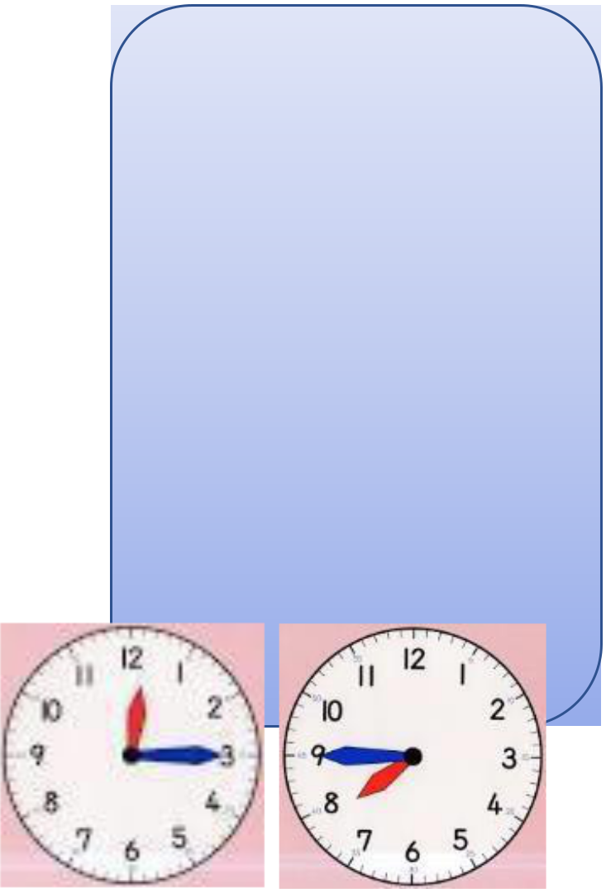

Children need to be able to tell the time using a clock with hands. This target can be broken down into several steps.

- I can tell the time to the nearest hour.

- I can tell the time to the nearest half hour.

- I can tell the time to the nearest quarter hour.

- I can tell the time to the nearest five minutes

Key Vocabulary Twelve o’clock Half past two Quarter past three Quarter to nine Five past one Twenty-five to ten

Top Tips - The secret to success is practising little and often. Use time wisely. Can you practise these KIRFs while walking to school or during a car journey? You do not need to practise them all at once; perhaps you could

have a fact of the day. If you would like more ideas, please speak to your child’s teacher.

Talk about time – Discuss what time things happen. When does your child wake up? What time do they eat breakfast? Make sure that you have an analogue clock visible in your house or that your child wears a watch with hands. Once your child is confident telling the time, see if you can find more challenging clocks e.g. with Roman numerals or no numbers marked.

Ask your child the time regularly – You could also give your child some responsibility for watching the clock:

•

•

‘The cakes need to come out of the oven at twenty-five minutes past four exactly.’ ‘We need to leave the house at twenty-five to nine.’

Key Instant Recall Facts

YEAR 3 – Summer 2

I know the multiplication and division facts for the 8 times table

By the end of this half term, children should know the following facts. The aim is for them to recall these facts instantly.

8 x 1 = 8 | 1 x 8 = 8 | 8 ÷ 8 = 1 | 8 ÷ 1 = 8
8 x 2 = 16 | 2 x 8 = 16 | 16 ÷ 8 = 2 | 16 ÷ 2 = 8
8 x 3 = 24 | 3 x 8 = 24 | 24 ÷ 8 = 3 | 24 ÷ 3 = 8
8 x 4 = 32 | 4 x 8 = 32 | 32 ÷ 8 = 4 | 32 ÷ 4 = 8
8 x 5 = 40 | 5 x 8 = 40 | 40 ÷ 8 = 5 | 40 ÷ 5 = 8
8 x 6 = 48 | 6 x 8 = 48 | 48 ÷ 8 = 6 | 48 ÷ 6 = 8
8 x 7 = 56 | 7 x 8 = 56 | 56 ÷ 8 = 7 | 56 ÷ 7 = 8
8 x 8 = 64 | 8 x 8 = 64 | 64 ÷ 8 = 8 | 64 ÷ 8 = 8
8 x 9 = 72 | 9 x 8 = 72 | 72 ÷ 8 = 9 | 72 ÷ 9 = 8
8 x 10 = 80 | 10 x 8 = 80 | 80 ÷ 8 = 10 | 80 ÷ 10 = 8
8 x 11 = 88 | 11 x 8 = 88 | 88 ÷ 8 = 11 | 88 ÷ 11 = 8
8 x 12 = 96 | 12 x 8 = 96 | 96 ÷ 8 = 12 | 96 ÷ 12 = 8

They should be able to answer these questions in any order, including missing number questions e.g. 8 x ⃞= 16 or ⃞÷ 8 = 7

What is 8 multiplied by 6? What is 8 times 8? What is 24 divided by 8?

Top Tips - The secret to success is practising little and often. Use time wisely. Can you practise these KIRFs while walking to school or during a car journey? You do not need to practise them all at once; perhaps you could have a fact of the day.

Songs and Chants – You can buy Times Tables CDs or find multiplication songs and chants online. You can also use Education City songs and websites www.timestables.co.uk and www.timestables.me.uk

Double your fours – Multiplying a number by 8 is the same as multiply by 4 and then doubling the answer. 8 x 3 = 24 and double 24 is 48, so 8 x 3 = 24.

Five six seven eight – fifty-six is seven times eight (56 = 7 x 8)

I ate and ate until I was sick on the floor – eight times eight is sixty-four (8 x 8 = 64)

Use memory tricks – For those hard-to-remember facts, www.multiplication.com has some strange picture stories to help children remember.

