


Aston All Saints Church of England Primary School



YEAR 6 Mathematics

Key Instant Recall Facts

KIRFs

To develop your child’s fluency and mental maths skills, we are introducing KIRFs (Key Instant Recall Facts) throughout school. KIRFS are a way of helping your child to learn by heart, key facts and information which they need to have instant recall of.

KIRFs are designed to support the development of mental maths skills that underpin much of the maths work in our school. They are particularly useful when calculating, adding, subtracting, multiplying or dividing. They contain number facts such as number bonds and times tables that need constant practise and rehearsal, so children can recall them quickly and accurately.

Instant recall of facts helps enormously with mental agility in maths lessons. When children move onto written calculations, knowing these key facts is very beneficial. For your child to become more efficient in recalling them easily, they need to be practised frequently and for short periods of time.

Each half term, children will focus on a Key Instant Recall Fact (KIRF) to practise and learn at home for the half term. They will also be available on our school website under the maths section and each child will receive a copy to keep at home. The KIRFs include practical ideas to assist your child in grasping the key facts and contain helpful suggestions of ways in which you could make this learning interesting and relevant. They are not designed to be a time-consuming task and can be practised anywhere – in the car, walking to school, etc. Regular practice - little and often – helps children to retain these facts and keep their skills sharp. Throughout the half term, the KIRFs will also be practised in school and your child’s teacher will assess whether they have been retained.

Over their time at primary school, we believe that - if the KIRFs are developed fully - children will be more confident with number work, understand its relevance, and be able to access the curriculum much more easily. They will be able to apply what they have learnt to a wide range of problems that confront us regularly.


Key Instant Recall Facts

YEAR 6 – Autumn 1

I know the multiplication and division facts for all times tables up to 12 x 12

By the end of this half term, children should know the following facts. The aim is for them to recall these facts instantly.

See separate sheet for all times tables facts.

This is a chance for Year 6 children to Consolidate their knowledge of multiplication and division facts and to increase their speed of recall.

They should be able to answer these questions in any order, including missing number questions

Key Vocabulary


What is 8 multiplied by 6?

What is 7 times 4?

What is 81 divided by 9?

What is the product of 5

and 7?

e.g. 6 x __ = 42 or __÷ 8 = 4

Children who have already mastered their times tables should apply this knowledge to answer questions including decimals

e.g. 0.7 x __= 4.2 or __÷ 60 = 0.6

Top Tips - The secret to success is practising little and often. Use time wisely. Can you practise these KIRFs while walking to school or during a car journey? You do not need to practise them all at once; perhaps you could have a fact of the day.

Speed challenge – Take two packs of playing cards and remove the kings. Turn over two cards and ask your child to multiply the numbers together (Ace = 1, Jack = 11 and Queen = 12). How many questions can they answer correctly in 2 minutes? Practise regularly and see if they can beat their highest score.

Online games – Activities on www.educationcity.com www.conkermaths.org www.timestables.co.uk and www.timestables.me.uk

Use memory tricks – For those hard-to-remember facts, www.multiplication.com has some strange picture stories to help children remember.

Key Instant Recall Facts

YEAR 6 – Autumn 2

I can identify common factors of a pair of numbers

By the end of this half term, children should know the following facts. The aim is for them to recall these facts instantly.


The factors of a number are all numbers which divide it with no remainder.

E.g. the factors of 24 are 1, 2, 3, 4, 6, 8, 12 and 24

the factors of 56 are 1, 2, 4, 7, 8, 14, 28 and 56.

The common factors of two numbers are the factors they share.

E.g. the common factors of 24 and 56 are 1, 2, 4 and 8

the highest common factor of 24 and 56 is 8.

Key Vocabulary

Factor

Common factor

Multiple

Highest common

factor

Children should be able to explain how they know that a number is a common factor. E.g. 8 is a common factor of 24 and 56 because 24 = 8 x 3 and 56 = 8 x 7

Top Tips - The secret to success is practising little and often. Use time wisely. Can you practise these KIRFs while walking to school or during a car journey? You do not need to practise them all at once; perhaps you could have a fact of the day.

Online games – Activities on www.educationcity.com, www.conkermaths.org www.timestables.co.uk www.timestables.me.uk and http://www.fun4thebrain.com/beyondfacts/gcfsketch.html

Play games - Choose two numbers. Take it in turns to name factors. Who can find the most?

NOTE – We do not expect children to know all the factors of a number instantly but would expect them to be able to work them out within a minute or so for numbers under 100

Key Instant Recall Facts

YEAR 6 – Spring 1

I know common decimals, fractions and percentage equivalences

By the end of this half term, children should know the following facts. The aim is for them to recall these facts instantly.

½ | = | 0.5 | = | 50%
¼ | = | 0.25 | = | 25%

- =0.75 = 75%
¹/10 | = | 0.1 | = | 10%
³/10 | = | 0.3 | = | 30%
¹/5 | = | 0.2 | = | 20%
³/5 | = | 0.6 | = | 60%
¹/100 | = | 0.01 | = | 1%
Etc…

Children should be able to convert between decimals, fractions and percentages for ½, ¼, ¾ and any number of tenths and hundredths.

Key Vocabulary

Write 0.75 as a fraction.

Write ¼ as a decimal.

What is ¾ as a

percentage?

Top Tips - The secret to success is practising little and often. Use time wisely. Can you practise these KIRFs while walking to school or during a car journey? You do not need to practise them all at once; perhaps you could have a fact of the day. If you would like more ideas, please speak to your child’s teacher.

Play games – Make some cards with equivalent fractions, decimals and percentages. Use these to play the memory game or snap. Or make your own dominoes with fractions on one side and decimals on the other.

Key Instant Recall Facts

YEAR 6 – Spring 2

I can identify prime numbers up to 50

By the end of this half term, children should know the following facts. The aim is for them to recall these facts instantly.


A prime number is a number with no factors other than one and itself.

The following numbers are prime numbers:

2, 3, 5, 7, 11, 13, 17, 19, 23, 29, 31, 37, 41, 43 and 47

A composite number is divisible by a number other than one and itself.

The following numbers are composite numbers:

Key Vocabulary

Prime number

Composite

number

factor

multiple

4, 6, 8, 9, 10, 12, 14, 15, 16, 18, 20, 22, 24, 25, 26, 27, 28, 30, 32, 34, 35, 36,

38, 40, 42, 44, 45, 46, 48, 49 and 50

Children should be able to explain how they know that a number is composite. E.g. 39 is a composite because it is a multiple of 3 and 13.

Top Tips

The secret to success is practising little and often. Use time wisely. Can you practise these KIRFs while walking to school or during a car journey? You do not need to practise them all at once; perhaps you could have a fact of the day.

It is very important that your child uses mathematical vocabulary accurately. Choose a number between 2 and 50. How many correct statements can your child make about this number using the key vocabulary above.

Make a set of cards for the numbers from 2 to 50. How quickly can your child sort these into prime and composite numbers? How many even prime numbers can they find? How many odd composite numbers can they find?

Please note that 1 is not a prime or composite number.

Key Instant Recall Facts

YEAR 6 – Summer 1

I know the formulae for finding the area of different shapes

By the end of this half term, children should know the following facts. The aim is for them to recall these facts instantly.

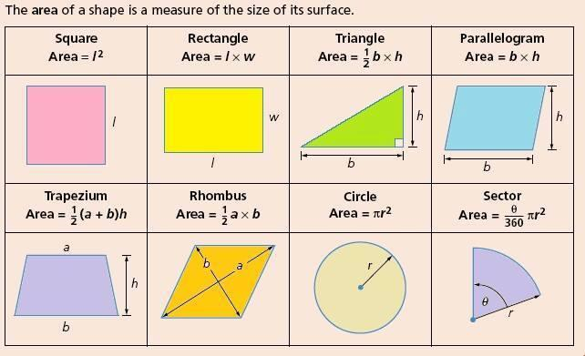

Children should also be able to recall the formula for finding the area of different shapes.

Top Tips - The secret to success is practising little and often. Use time wisely. Can you practise these KIRFs while walking to school or during a car journey? You do not need to practise them all at once; perhaps you could have a fact of the day.

It is very important that your child uses mathematical vocabulary accurately. They must use language such as height, length, base, width and radius when recalling the appropriate formulae.

Key Vocabulary

Area

Base

Height

Pi

Radius

Key Instant Recall Facts

YEAR 6 – Summer 2

I know the first 5 cube numbers

By the end of this half term, children should know the following facts. The aim is for them to recall these facts instantly.

Cube number is any number multiplied by itself three times.
E.g. n x n x n. It can be written as n³

The first five cube numbers are:

1 x 1 x 1 = 1

2 x 2 x 2 = 8

3 x 3 x 3 = 27

4 x 4 x 4 = 64

5 x 5 x 5 = 125

Children should be able to explain what a cube number is and recall the first five cube numbers quickly.

Use visual images to help children understand what a cube number is.

Key Vocabulary


Cube number

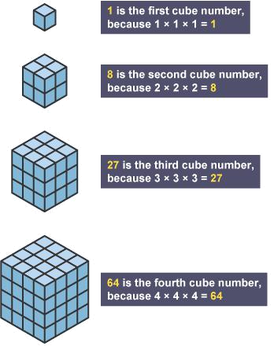

Top Tips - The secret to success is practising little and often. Use time wisely. Can you practise these KIRFs

while walking to school or during a car journey? You do not need to practise them all at once; perhaps you could have a fact of the day. If you would like more ideas, please speak to your child’s teacher.

